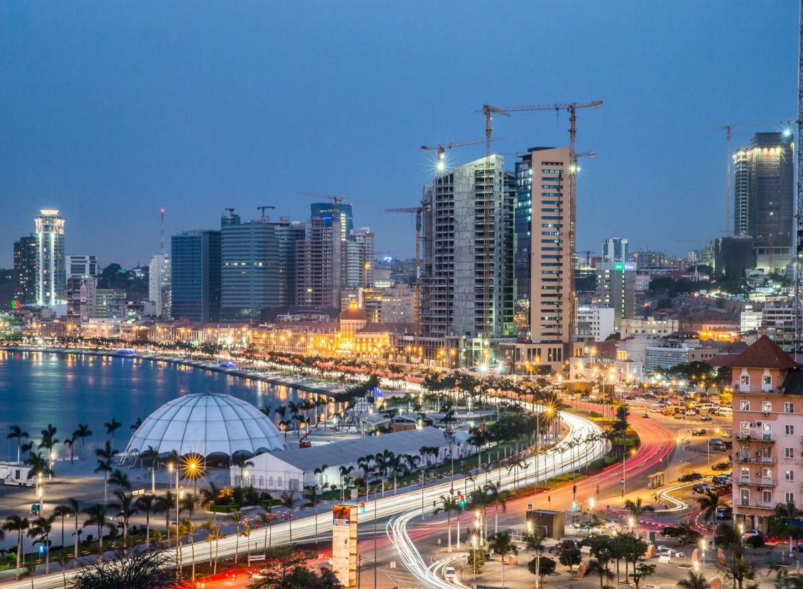 Luanda City

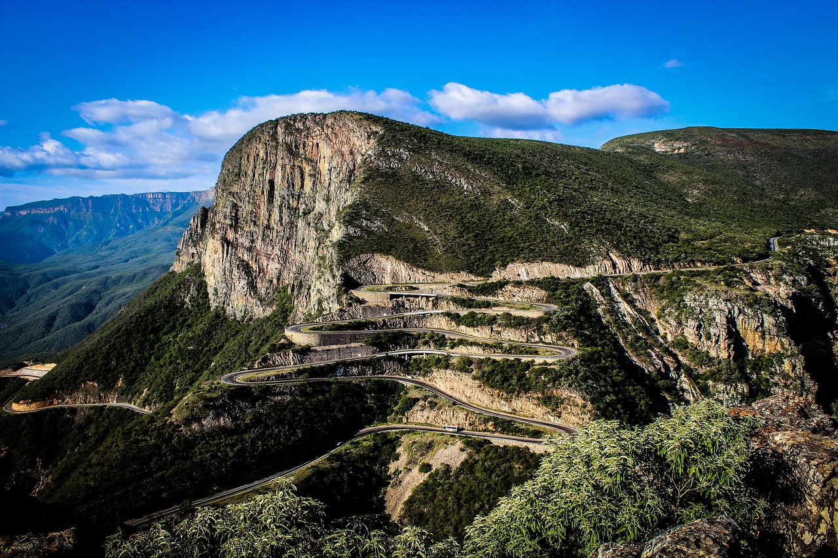This for the main home page – Serra da Leba.

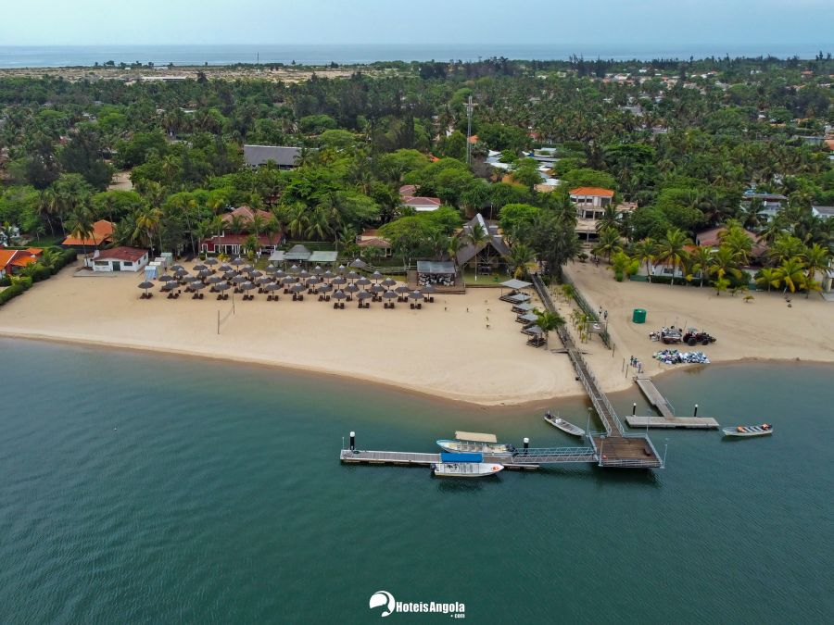

Roca das Mangueiras – Mussulo in Luanda

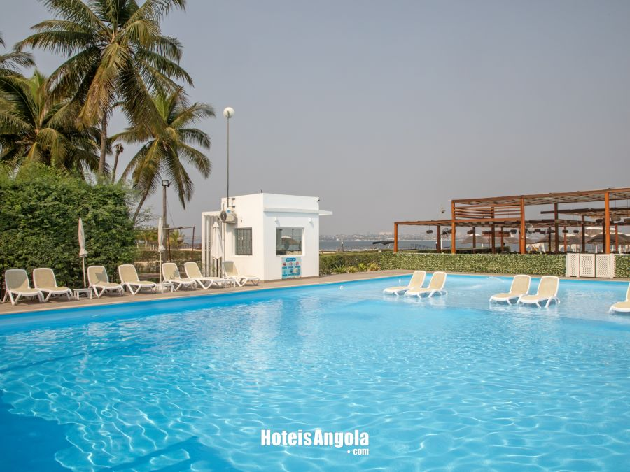

Dallys Resort – Mussulo in Luanda

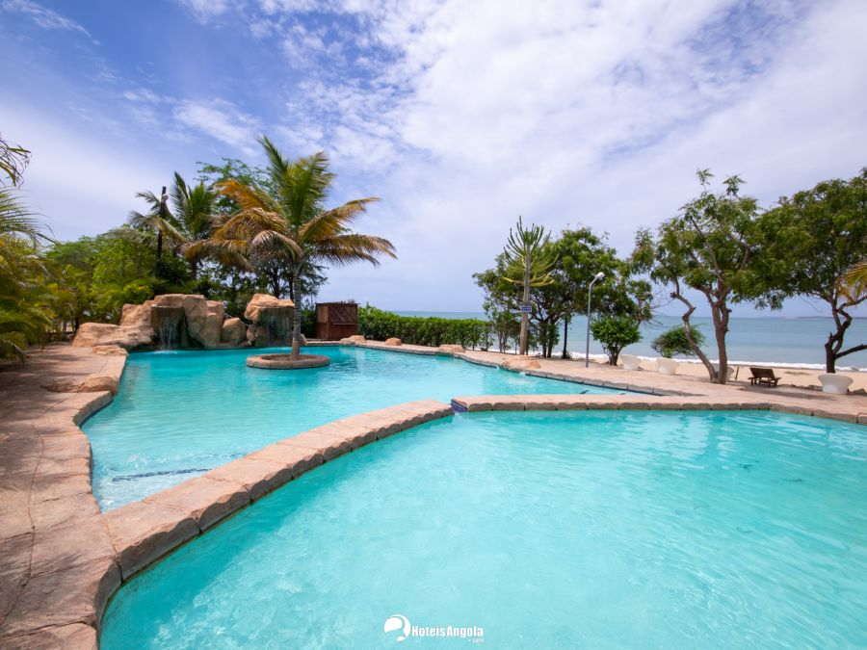

Cabo Ledo = Complexo Turistico Doce Mar